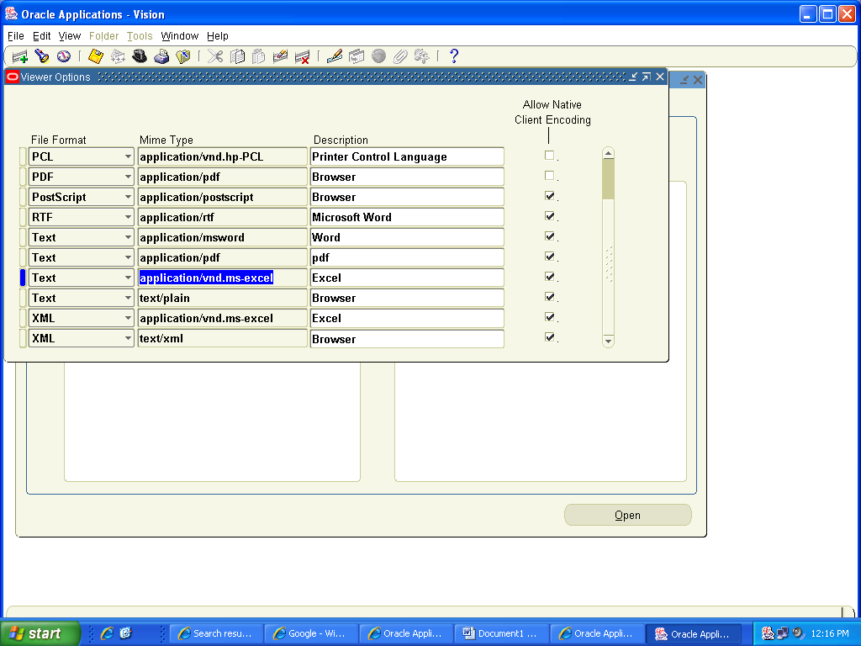
This foure comes in LOV, But in Msword And
Normal browser it is working fine . but pdf and excel it does int appeare..

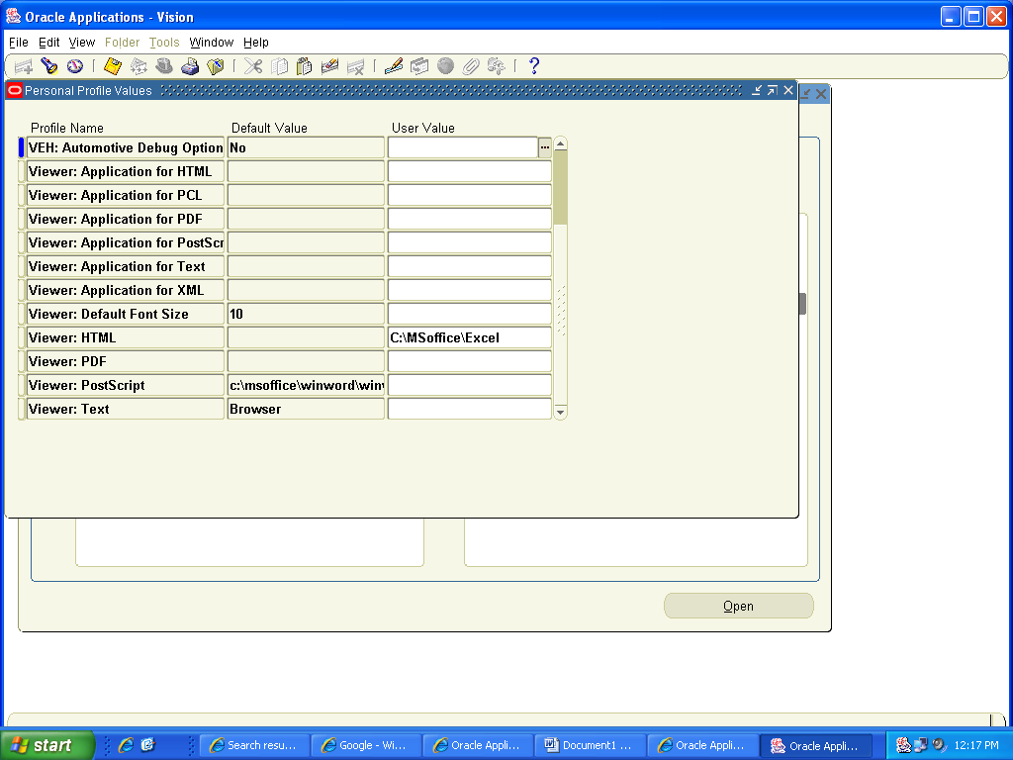
Only this is BROWSER.others are blank

